Intergenerational Justice Fund – Draft website content
17 September 2026
- Home page
Keep all the proposed colours and themes.
Please update the information in the black box as follows:
“Intergenerational Justice Fund
We use the law to drive systemic change, targeting issues that will cause escalating harm to future generations if left unaddressed.”

Please remove the “support our work” etc tabs.

Please add the following to the bottom of the Home page: Intergenerational Environment Justice Fund (ABN 51 656 623 719) to

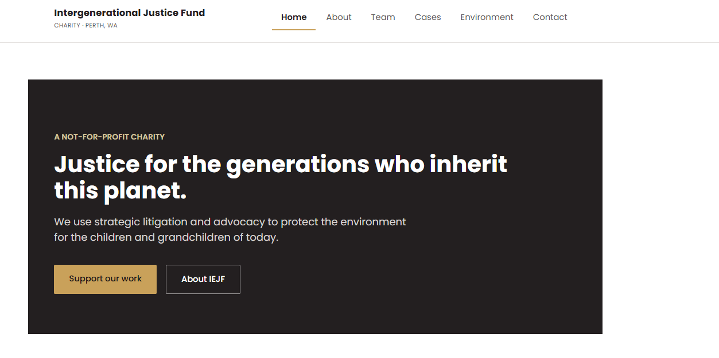
- About us
Intergenerational Justice Fund Limited is an Australian charity dedicated to advancing charitable purposes for the public benefit that carry an intergenerational impact.

We use the law to drive systemic change, targeting issues that will cause escalating harm to future generations if left unaddressed. To that end, we build and fund strategic collaborations in Australia and overseas on charitable projects spanning strategic litigation, advocacy for legislative and regulatory reform, research and investigations, shareholder action, communication and education.

Our work is anchored in three complementary focus areas:
- Environment – We advance the protection, promotion and enhancement of the natural environment through our own research and by funding research and legal action (Intergenerational Environment Justice Fund Limited ABN 51 656 623 719).
- Health – Our focus is promoting the prevention or control of human diseases through our own research and by funding research and legal action (Intergenerational Health Justice Fund Limited ABN 28 658 260 194).
- Human Rights - Our purpose is to prevent and control behaviours that harm people, with a focus on emotional abuse, physical abuse, suicide and self-harm. We address these harms through education, research, legal action and advocacy (Intergenerational Human Rights Justice Fund Limited ABN 23 659 732 331.

- Insights
[Please leave blank for now – just keep as a placeholder]

- Contact
Perth, WA
hello@justicefund.org.au

Please remove the ‘Get in touch’ box

